# Chemistry Allocation System V2

## Step 1: Set the configuration data

The Program is now designed to work in many ways depending on the configuration. Run the program and click the cog icon in the top right of the screen.

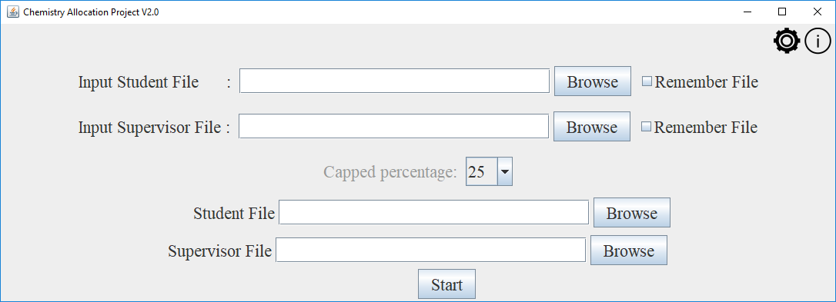

The configuration data is split into 3 categories, student, supervisor and matching.

* Student - The student section contains indexes into the student input data. When the program is pointed to a student file it needs to be told what columns are where. Which column is the username column? What columns are the choice columns? Which are the keyword columns? Etc.
* Supervisor - The supervisor section contains indexes into the supervisor input data. When the program is pointed to a supervisor file it needs to be told what columns are where. Which column is the supervisors name? Which is the supervisor capacity?
* Matching – The Matching section contains data that describes how the match will work. Is keyword allocation to be used? Is topic area allocation to be used?

## Step 2: Select the input files

Use the input sections on the main page to select the student and supervisor input files

## Step 3: Check the configuration data

Once you have set the configuration data and the input files, it is *highly* recommended you view the data to make sure it all makes sense. On the home screen press the i icon in the top right.

Like the configuration the data is split into 3.

* Student – The student data will show the column names with what the program interprets them as. For example, in the image below the program is telling you that it is using the column with the header “Username” as the username column

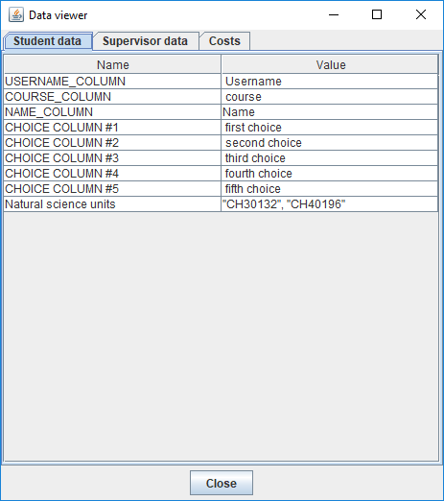

* 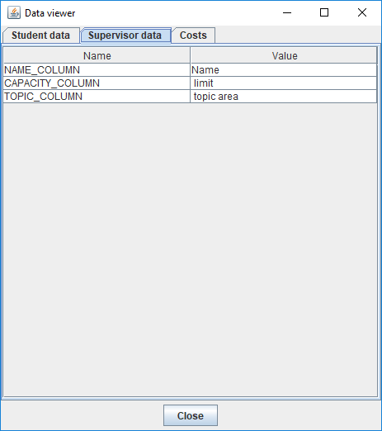Supervisor – The supervisor data will show the column names with what the program interprets them as. For example, in the image below the program is telling you that it is using the column with the header “limit” as the supervisor capacity column
* Costs – The cost section shows you a table of costs that the program uses in the matching. The table is ordered and shows you what the program considers to be the best matching and what it considers to the worst matching. In the example below the cost of preference rank 1 is 1 and preference rank 5 has a value of 15. Use this page to weigh topic area, keywords and preference choices and tweak the configuration.

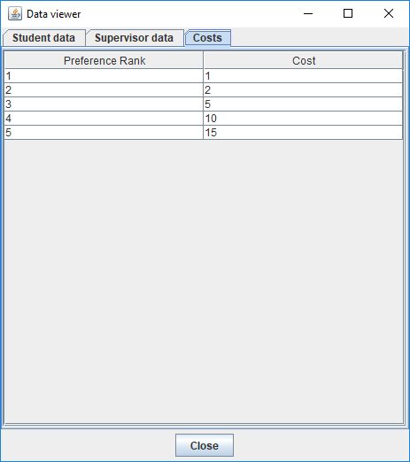

## Step 4: Match

Perform the allocation and view outputs